Sarah’s Reading List

Beyond Disruption, Changing The Rules in the Marketplace, Jean-Marie Dru

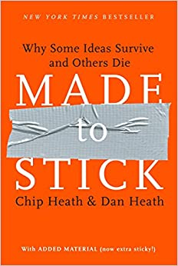

Made to Stick, Why Some Ideas Survive and Others Die, Chip Heath & Dan Heath

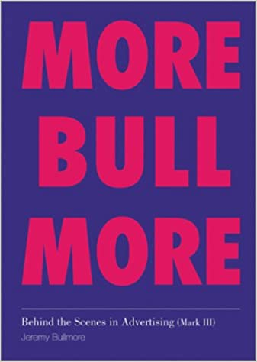

Behind the Scenes in Advertising, Jeremy Bulimore

Sex, Drugs and Cocoa Puffs, A Low Culture Manifesto, Chuck Klosterman

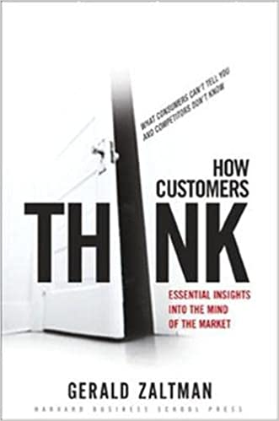

How Customers Think, Essential insights into the Mind of the Market, Gerald Zaltman

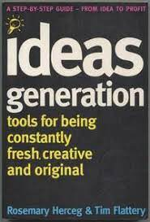

Ideas Generation: Tools for Being Constantly Fresh, Creative and Original, Rosemary Herceg & Tim Flattery

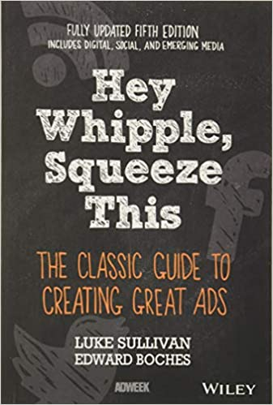

Hey Whipple, Squeeze This, A Guide to Creating Great Ads, Luke Sullivan

Purple Cow, Transform your Business by Being Remarkable, Seth Godin

Cognitive Surplus, How Technology Turns Consumers Into Collaborators, Clay Shirky

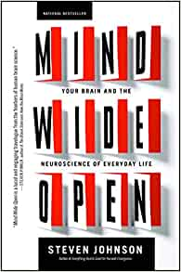

Mind Wide Open, Your Brain and the Neuroscience of Everyday Life, Steven Johnson

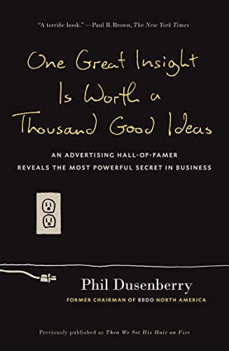

One Great Insight is Worth A Thousand Good Ideas: An Advertising Hall-of-Famer reveals the Most Powerful Secret in Business, Phil Dusenberry

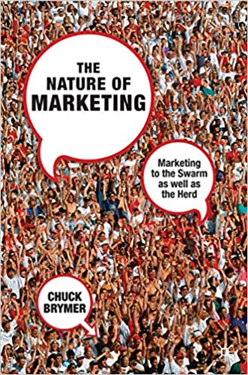

The Nature of Marketing, Marketing to the Swarm as Well as the Herd, Chuck Brymer
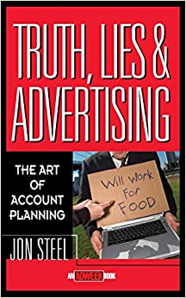

Truth, Lies and Advertising, The Art of Account Planning, Jon Steel

Brand New Brand Thinking, edited by Merry Baskin & Mark Earls

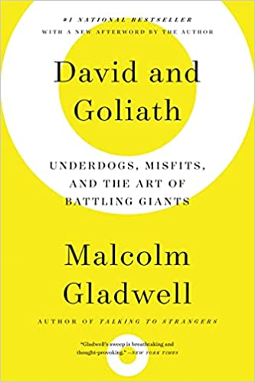
David and Goliath, Underdogs, Misfits and the Art of Battling Giants, Malcolm Gladwell

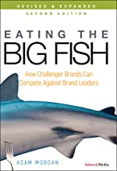
Eating the Big Fish, How Challenger Brands Can Compete Against Brand Leaders, Adam Morgan

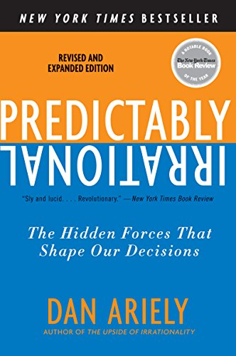
Predictably Rational, Dan Ariely

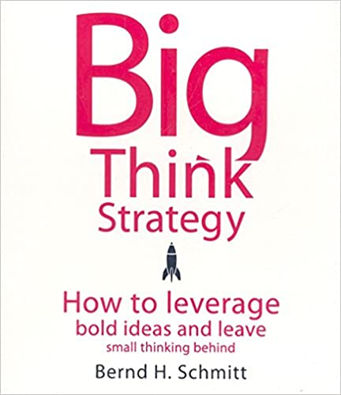

Big Think Strategy, How to leverage bold ideas and leave small thinking behind, Bernd H. Schmitt
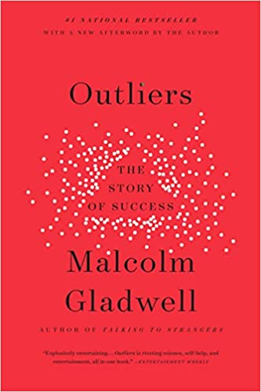

Outliers, The Story of Success, Malcolm Gladwell

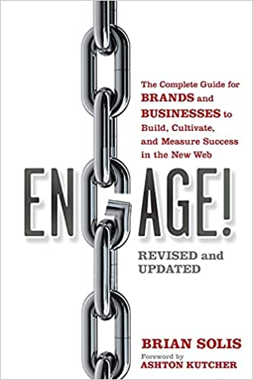

Engage! Brian Sollis

How to Plan Advertising, Alan Cooper

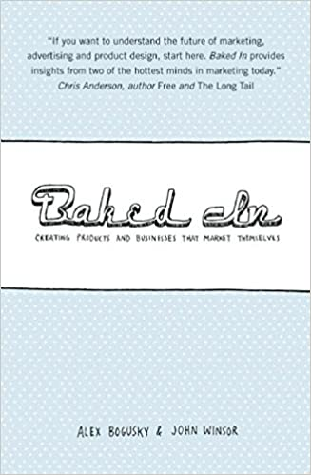
Baked In, Creating Products and Business that Market Themselves, Alex Bogusky & John Winsor

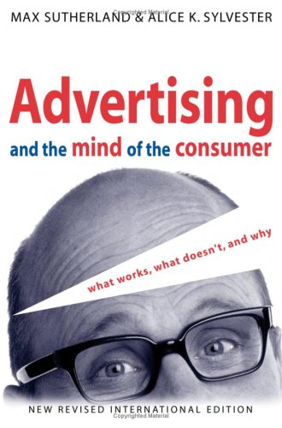

Advertising and The Mind of the Consumer, Alicia Sylvester

